Final Report

Goethe Cruz # 11720991

Will Dunavin # 11627304

Zach Musick # 11495153

Teas Tech University

December 2021

Abstract

This paper describes the components and interactions thereof that make up a system to navigate a metallic tape track and change speed and direction depending on a specific color presented on the track. The project uses a combination of hardware, such as circuits, and software in the form of Vivado Studio and Verilog to achieve this goal. First, a brief overview of the project composition will be discussed, followed by a block diagram to help illustrate the project. Next, the necessary components will be reviewed and explained, followed by the circuitry designed. After a description of the circuits and their parts, the code written is discussed and succeeded by the conclusion.

Table of Contents

List of Figures v

1. Introduction 1

2. Body 2

2.1 Overview 3

2.2 Basys-3 Board 3

2.3 Breadboard 3

2.4 Rover 4

2.5 Computer 4

2.6 H-Bridge 6

2.7 Protoboard 6

2.8 Circuitry 6

2.9 RGB Color Sensor 6

3. Code 7

4. Conclusion 13

References 15

Appendix A 16

# List of Figures

Figure 1: Block Diagram. 2

Figure 2: Basys-3 Board Labeled. 4

Figure 3: Transistors Found Inside H-Bridge 6

Figure 4: Protoboard Circuitry. 7

Figure 5: Voltage Regluator Circuit And Simulation 8

Figure 6: IPS/Optocoupler Schematic. 9

Figure 7: Potentiometer/Proximity Sensor Circuit. 10

Figure 8: Battery Protection Schematic. 11

Figure 9: Custom Battery Protection PCB. 11

Figure 10: Duty Cycle Code Segment. 13

Figure 11: Duty Cycle Testbench 13

Figure 12: PWM Code Segmnent. 14

Figure 13: IPS Conditional Code Segment. 15

Figure 14: Code Flowchart. 16

Figure 15: O-Scope Frames; Top: Red Object, Clear Filter, Bottom: No Object, Clear Filter. 17

Figure 16: Blue Mode Conditional Statement. 18

Figure 17: Top Code Flowchart. 19

Figure 18: Budget. 23

Figure 19: Labor Chart. 23

Figure 20: Gantt Chart. 24

# 1. Introduction

The goal of this project was to build a robot capable of navigating a track composed of reflective metallic tape and wooden blocks of different colors. Three different colors dictate what the robot will do. The green colored block signals the rover to advance at high speed while navigating the track. The red color signals the rover to come to a complete stop. The blue color signals the rover to slow down and continue on an alternate path on the track. Furthermore, when the rover detects an obstacle on its path, the rover stops before contacting the obstacle. With these goals in mind, this paper will be a technical description of both the hardware and software designed and implemented to complete this goal.

2. Body

2.1 Overview

Overall project diagram. The overall project is an assembly of the Basys-3 board, h-bridge, the circuits located on the protoboard, the power sources, and the sensors used to achieve the navigation goals for this project. This section of the report will describe each component of the overall project assembly and its relation to the other components.

Figure 1: Block Diagram [7]

This block diagram helps to illustrate the relationship between each component. The 9.8 Volt battery first enters a battery protection circuit. This is to prevent damage in the event of the battery being plugged in backwards. Protected power then feeds into the 5 V regulator circuit, h-bridge board, and inductive proximity sensor circuit. The 5 V regulated power is fed into the Basys-3 Board and powers it safely. The rest of the blocks are intermittently sending and receiving signals to and from the Basys-3 Board which then performs the functions specified later in this paper.

2.2 Basys-3 Board

The Basys-3 board is the central communication piece of the assembly. This board receives information, such as frequency signals, voltage readings, and inductive feedback and dictates what component performs which task. The board is a “ready-to-use digital circuit development platform” [1]. These connections allow for communication between the board and all its other components. For this project, the parts utilized include the 7-segment digital display, the micro-USB port, the 4 P-mod ports and the LED’s on the board.

Figure 2: Basys-3 Board Labeled [1]

2.3 Breadboard

The Breadboard is simply a platform to create solderless circuits with the use of cables to connect various power sources, impedances, lights, motors, etc. This was useful for designing and prototyping the various circuits used throughout this project, for example the 9 V to 5 V regulator circuit, the battery protection circuit, etc. The breadboard is not part of the final design, rather, protoboards and specifically designed PCB’s are present in leu of any solderless boards.

2.4 Rover/Tank

The rover, or tank, houses 2 DC motors within its plastic body that can activate to rotate the treads located on either side of the body. The rover used does not contain enough space within the body to house all the necessary components, so a secondary platform holds all the boards that are needed for proper functionality of this project.

2.5 Computer

A laptop provided the software to hardware interface needed to write to the Basys-3 board. Another benefit of using an external power supply is that of protection from negative feedback power damaging the laptop being used.

2.6 H-Bridge

The H-bridge board consists of various electronic components such as enable pins, enable LED’s, 3 pin ports for the motors, various diodes for current direction, capacitors that help minimize noise and increase voltage stability and many other parts, as shown in Figure 2. However, the most useful piece is its name’s sake, the h-bridge. The h-bridge is a circuit consisting of 4 transistors, represented in Figure 3 as switches. Since the DC motor used for this project has two possible directions of rotation, a tool that can alternate between these directions is advantageous. By closing either switch one and three, or switch two and four, current flow within the h-bridge can control the direction of the motors’ spin. When used in conjunction with the IPS’s, the h-bridge allows the wheels of the rover to spin in opposite directions simultaneously, which is crucial for lower degree turns. Code is written to satisfy the desired conditions.

Figure 3: Transistors Found Inside The H-Bridge [2]

2.7 Proto Board

A protoboard is used to optimize workspace as well as to make the circuits built more permanent. The use of a protoboard also allows for space conservation and makes the circuits much easier to understand. The biggest advantage, however, is the near absence of jumper cables and wires that would otherwise hinder the functionality and aesthetics of the final product. To work without the worry of having any contact issues, which could result in damage to not only the specified circuit, but to other components of the project as well, should be noted as another valuable advantage. The circuits integrated onto the protoboard are the IPS circuits, the proximity sensor and potentiometer circuit, and the voltage regulator circuit.

Figure 4: Protoboard Circuitry

2.8 Circuitry

A variety of circuits were required to achieve the project goals. First, power is fed to a battery protection circuit in order to prevent any damage to the other circuits in the event of a battery plug in mistake. From there, to get power from the 9 V battery to the Basys-3 Board, a voltage regulator circuit was designed using the LM340T5 Regulator. This circuit includes two capacitors to limit the noise during use. This was chosen due to its simplicity to implement and ease of testing. An LED is included in the design to allow the user to confirm the circuit is active. The simulation results in Figure 5 demonstrate the original 9.6 V input, shown by the blue line, successfully being regulated to 5 V, shown by the green line.

Figure 5: Voltage Regulator Circuit And Simulation

Secondly, the LJC 18A3-H-Z/BX Inductive Proximity Sensors require 6 V to 36 V power supplied for nominal functionality. Given this, the voltage output from the reverse polarity circuit can be directly used, without the need for any regulatory circuit to power these sensors. This sensor works by detecting a loss in a magnetic field due to inductive currents generated from a conductive surface [4]. Power enters the circuit of IPSs and an optocoupler, which physically separates two parts of a circuit under certain conditions. This reduces the power of the sensors from their supplied power, down to 3.3 V, which will not damage the Basys-3 Board.

Figure 6: IPS/Optocoupler Schematic

Thirdly, the proximity sensor circuit was used to power the Pololu Proximity sensor and a potentiometer. The given range of the proximity sensor is 2 cm to 10 cm. Since the distance from the rover to the obstacle is unknown, a 1kΩ potentiometer was used in order to vary the effective range of the sensor easily and allow the rover to better navigate the track. This allows the robot to detect and stop when an obstacle is present, satisfying one of the project goals.

Figure 7: Potentiometer/Proximity Sensor Circuit

Finally, the custom PCB. In order to protect the power source from any potential harm, a reverse polarity protection circuit is designed and implemented using a diode and a fuse, as was previously mentioned. A diode is used to bias the direction of the current flowing through the circuit. The diode selected has a relatively low amperage rating, so a fuse is also implemented to compensate in the event too much current is drawn. When the battery is plugged in correctly, power flows from the input directly through a resistor and LED to signal to the user that the circuit is active. Power will also flow to two outputs both measuring 9.6 V. When the battery is plugged in the opposite manner, power will flow through the diode and into the fuse, blowing the fuse and preventing any further damage to the rest of the circuit.

Figure 8: Battery Protection Schematic

Figure 9: Custom Battery Protection PCB

2.9 RGB Color Sensor

In order to fulfill what is arguably the most important piece of the project, the TCS3200 Color Sensor Module was chosen due to its voltage range, size, and code compatibility. The chip can convert light into a frequency, which can then be read by the Basys-3 board and provides usable data for coding. It has 64 photodiodes divided into 4 groups of 16, one for red, blue, green, and clear. This component operates a range of 2.7 V to 5.5 V, which is within the acceptable voltage range for use with the Basys-3 Board. The chip has 4 select pins, 2 of which can be used to choose the desired photodiode groups, while the remaining 2 are used to scale the frequency. See figure 16.

3. Code

Vivado and Verilog are the software used for writing to the Basys-3 board. Using Verilog, a hardware description language, allowed for a low-level program to be written to join the various components of the final assembly together. Much of the code for running the DC motors can be reused for a part of this project. The idea of Pulse Width Modulation, where in which a periodic signal with a specific frequency produces what is called a Duty Cycle, is still utilized for achieving the goals of this project.

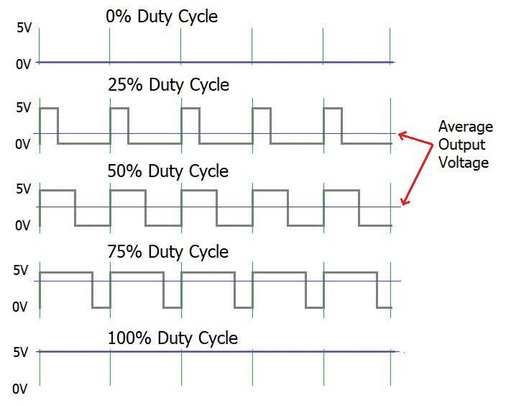

Figure 10: Duty Cycle Code Segment [5]

Using the first equation referenced in the Equations section of this paper, the correct percentages that correspond with the duty cycles were found and used in this project. The width of each square wave in Figure 10 represents the length when the frequency is high.

Figure 11: Duty Cycle Testbench

In the figure above, a clear distinction is shown between the different pulse widths of the square waves.

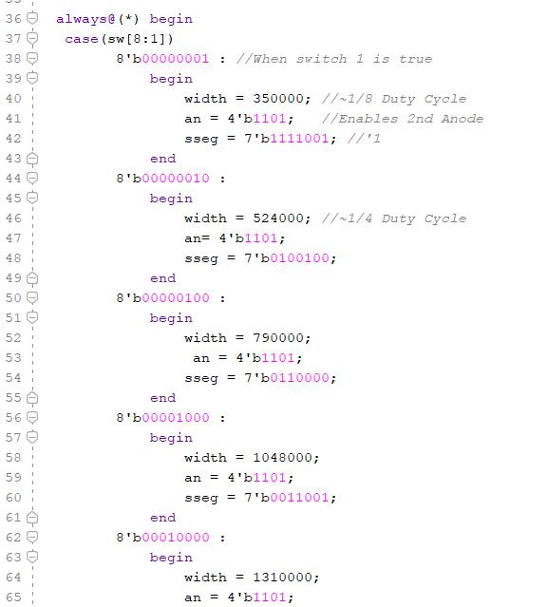

Figure 12: PWM Code Segment [5]

For the IPSs, code was written to allow for the output of the sensor to be read by the Basys-3 board and change the direction of the motor. For this code segment, the speed of the motor is not relevant, as the speed is dictated only by the frequency read by the RGB sensor and the proximity sensor. The data from the proximity sensor will turn the motor on or off depending on whether an obstacle is absent or not.

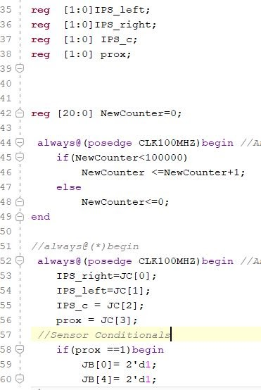

Figure 13: IPS Conditional Code Segment [6]

Code was written with a PWM hierarchy in mind. The RGB sensor takes the greatest priority when dealing with the speed of the motors. Recall, one of the goals of this project is for the robot to navigate a track according to the color it detects. If the IPS is detecting the metallic tape track but the RGB sensor is detecting a red signal, then the robot must not move. This leads to the RGB sensors’ data being the most important. This is reflected in the code flowchart.

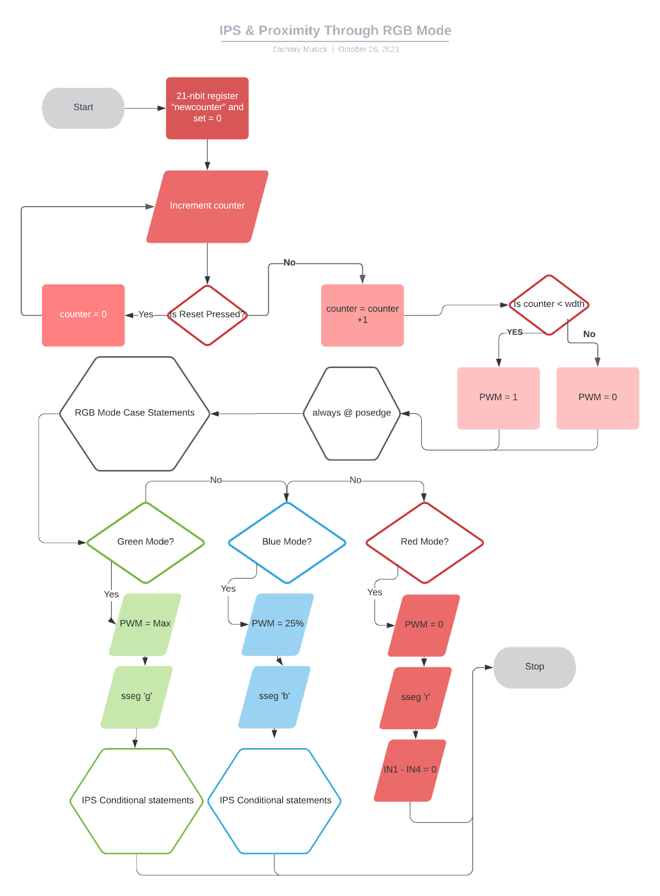Figure 14: Code Flowchart [6]

The data in Figure 15 contributed to the design of the code for the color detection aspect of the project. The frequencies shown correlate to specific colors as interpreted by the four clusters of photodiodes present on the TCS3200 color sensor chip. These frequencies also were used to develop conditional statements based on the color detected as shown for the blue conditional statement in Figure 16.

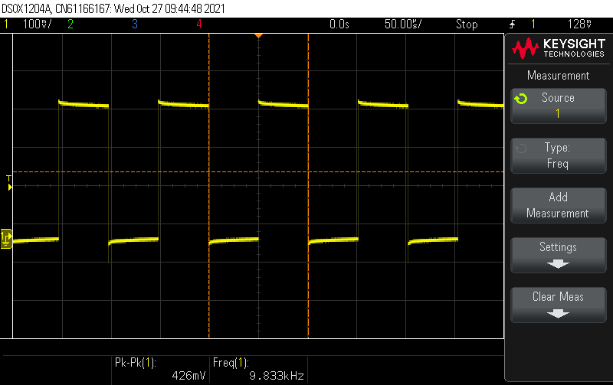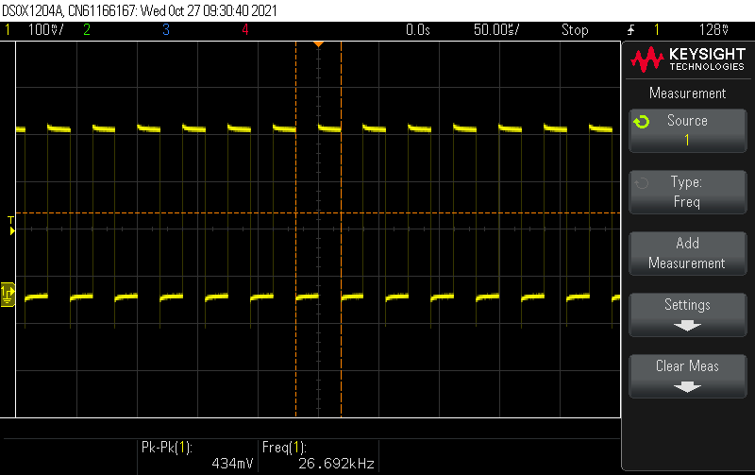

Figure 15: O-Scope Frames; Top: Red Object, Clear Filter, Bottom: No Object, Clear Filter

Figure 16: Blue Mode Conditional Statement [10]

Figure 17: Top Code Flowchart

4. Conclusion

In conclusion, the project to have a robot navigate a track utilizes various circuits, including a power regulating circuit, P-mod circuit, battery protection circuit etc. and code writing software like Verilog and Vivado. A hierarchy of sensor input priority is coded in order for the rover to first identify the frequency of color, then the output of the proximity sensor, and finally the feedback from the IP sensors. The Basys board serves as the main control center for the robot, communicating with the other components, and allows for apt control of the robot. With all these systems working in conjunction with each other, the robot can successfully navigate a track composed of a reflective, metallic tape, while changing its condition based upon not only which color the RGB sensor detects, but also the presence of an obstacle. This fulfills the goals discussed in the introduction of this paper.

# Equations

# (1)

(2)

(3)

# References

1. Digilent. “Basys 3 FPGA Board Reference Manual”, April 8 2016 <https://digilent.com/reference/_media/basys3:basys3_rm.pdf(09/16/21)>.
2. Dahl, Oyvind. “What Is an H-Bridge?”, December 5 2018< <https://www.build-electronic-circuits.com/h-bridge/> >(09/12/21).
3. Raj, Aswinth. “What is PWM. Pulse Width Modulation”, September 19 2018 <<https://circuitdigest.com/tutorial/what-is-pwm-pulse-width-modulation>> (09/18/21).
4. “ProximitySensors”, < <https://www.ia.omron.com/support/guide/41/introduction.html#:~:text=Inductive%20Proximity%20Sensors%20detect%20magnetic,a%20metallic%20object%20are%20detected>. > (10/30/21).
5. Musick, Zach. Laboratory Notes, 30 October 2021.
6. Musick, Zach. E-Mail Photographs, 30 October 2021
7. Dunavin, Will. Laboratory Notes, 30 October 2021.
8. Dunavin, Will. E-Mail Photographs, 31 October 2021
9. Dunavin, Will. E-Mail Schematic, 29 October 2021
10. Musick, Zach. Laboratory Notes, 11 November 2021
11. Musick, Zach. Laboratory Notes, 15 November 2021
12. Kelly, Mitchell. “Microcontrollers with Assembly”. Texas Tech University. Fall 2021

# Appendix A

Figure 18: Budget

Figure 19: Labor Chart

Figure 20: Gantt Chart